**Union and Draw School**

Comp 3322 - Software Engineering

Final Project Report

**Submitted by**

Ihsan Karagol

Damlanur Onat

Rowshen Paltayew

Bakybek Tazhibaev

Computer Science Department

May 07, 2017

**Table of Contents**

1. **Introduction**
2. **Project Organization**

2.1 Software Process Model

2.2 Roles and Responsibilities

1. **Project Management Plan**

3.1 Tasks

3.2 Assignments

3.3 Timetable

1. **Additional Material**

5.1 Screenshots

INTRODUCTION

A brief description of the website that we did.

1.1 Requirements Analysis

1.1.1 Context of the project.

Discuss the scope of the project here..

1.1.2 Explain the need and how this project will address it?

What customer needs. How do you address those needs?

2 PROJECT ORGANIZATION

2.1 Software Process Model

 We selected Software **Prototyping Process model** for our website project. It went The advantages of using Prototype model in our project were: We could better understand requirements for user functionality, and interface, since we can actually going into final development stage. It enabled us to add

2.2 Roles and Responsibilities

Description of each members’ contributions and roles.

3 PROJECT MANAGEMENT PLAN

3.1

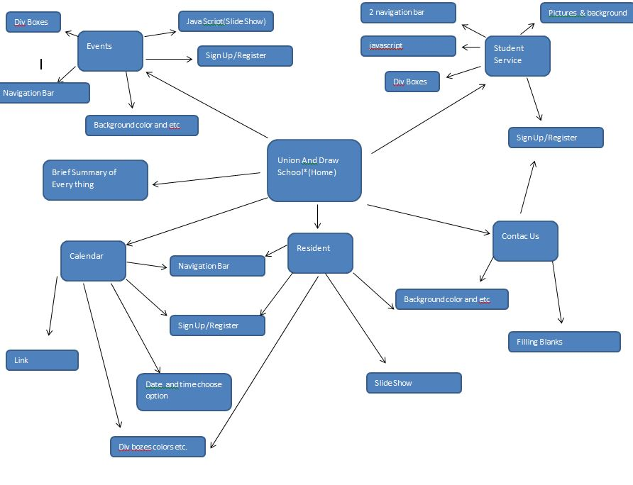

3.2 Assignments

Who worked on which part.

* Ihsan Karagol
  + Home
  + Sign Up
  + Student Service
  + Login/Register
* Damlanur Onat
  + Resident
* Rowshen Paltayew
  + Calendar
* Bakybek Tazhibaev
  + Events

4 TEST

4.1 Features Tested

1. Main Html
2. Logo sizes
3. Website name
4. Student Service
5. Resident
6. Calendar
7. Events
8. Sign Up /Login page
9. Colors and design

5.1 Saved Place for videos and screen shots

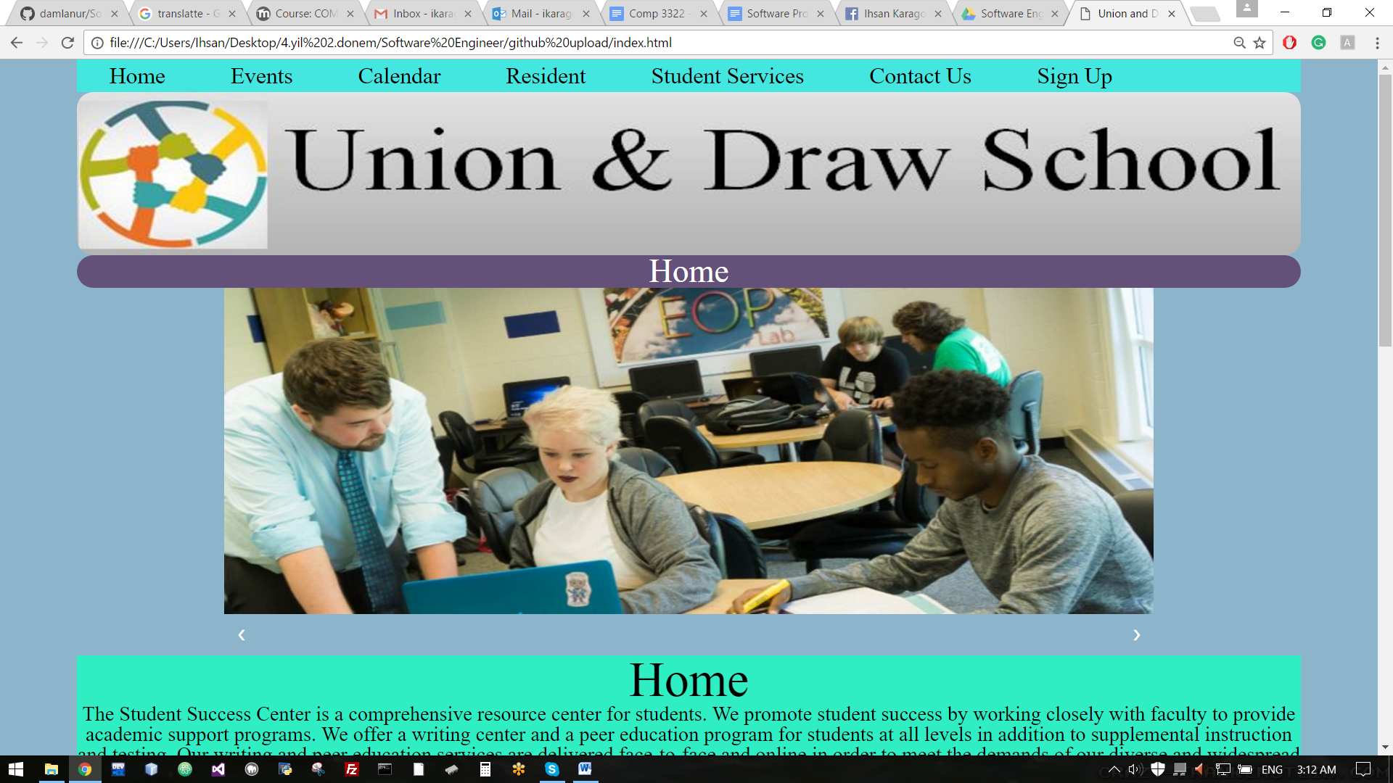 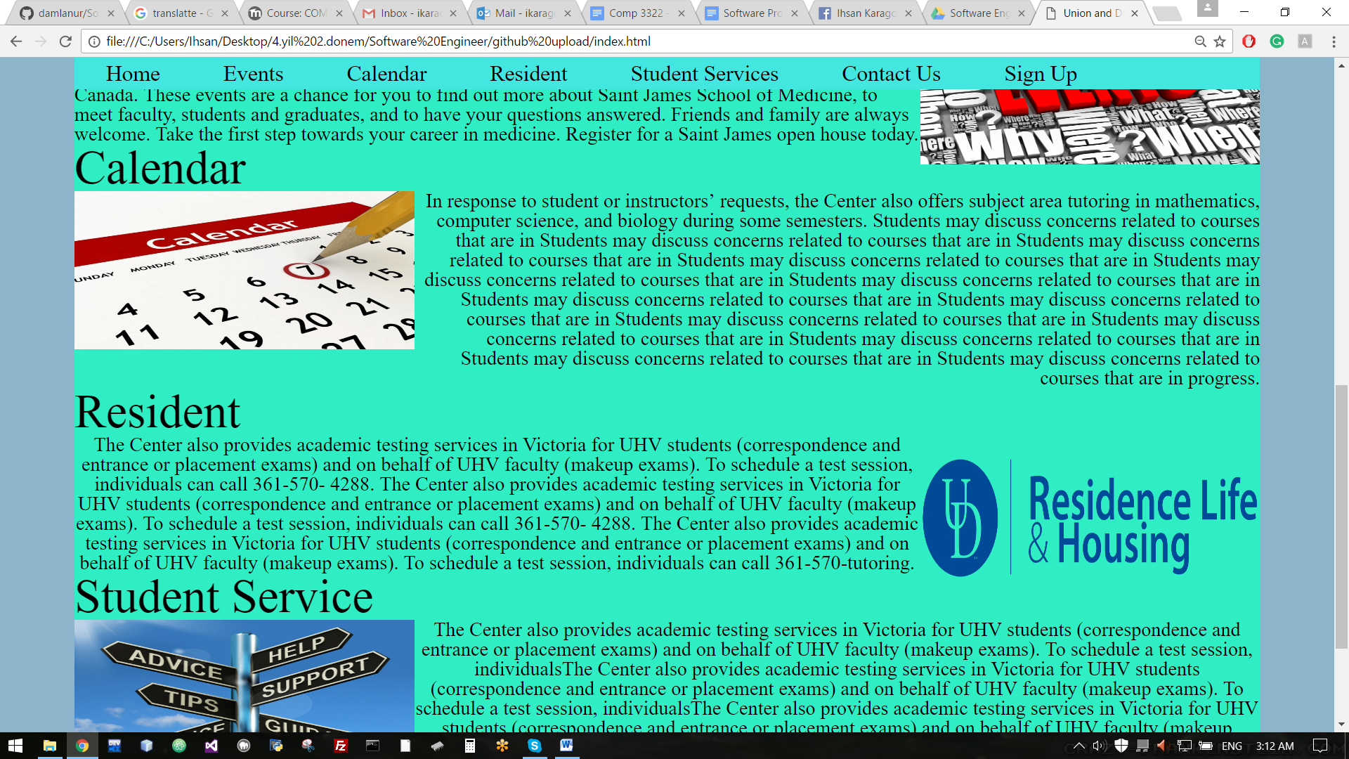 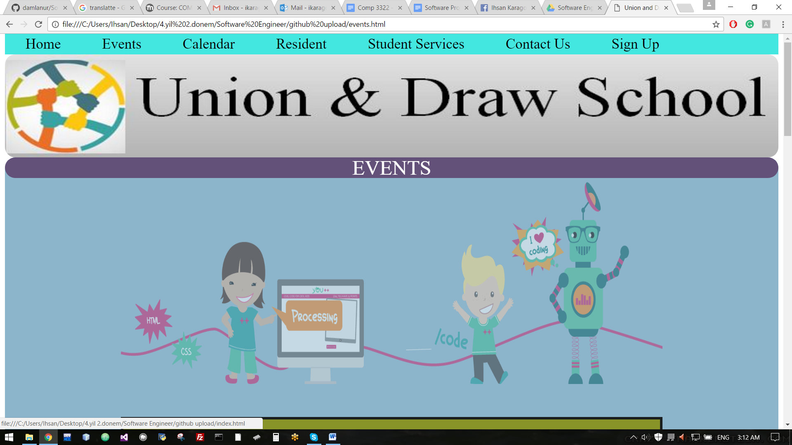 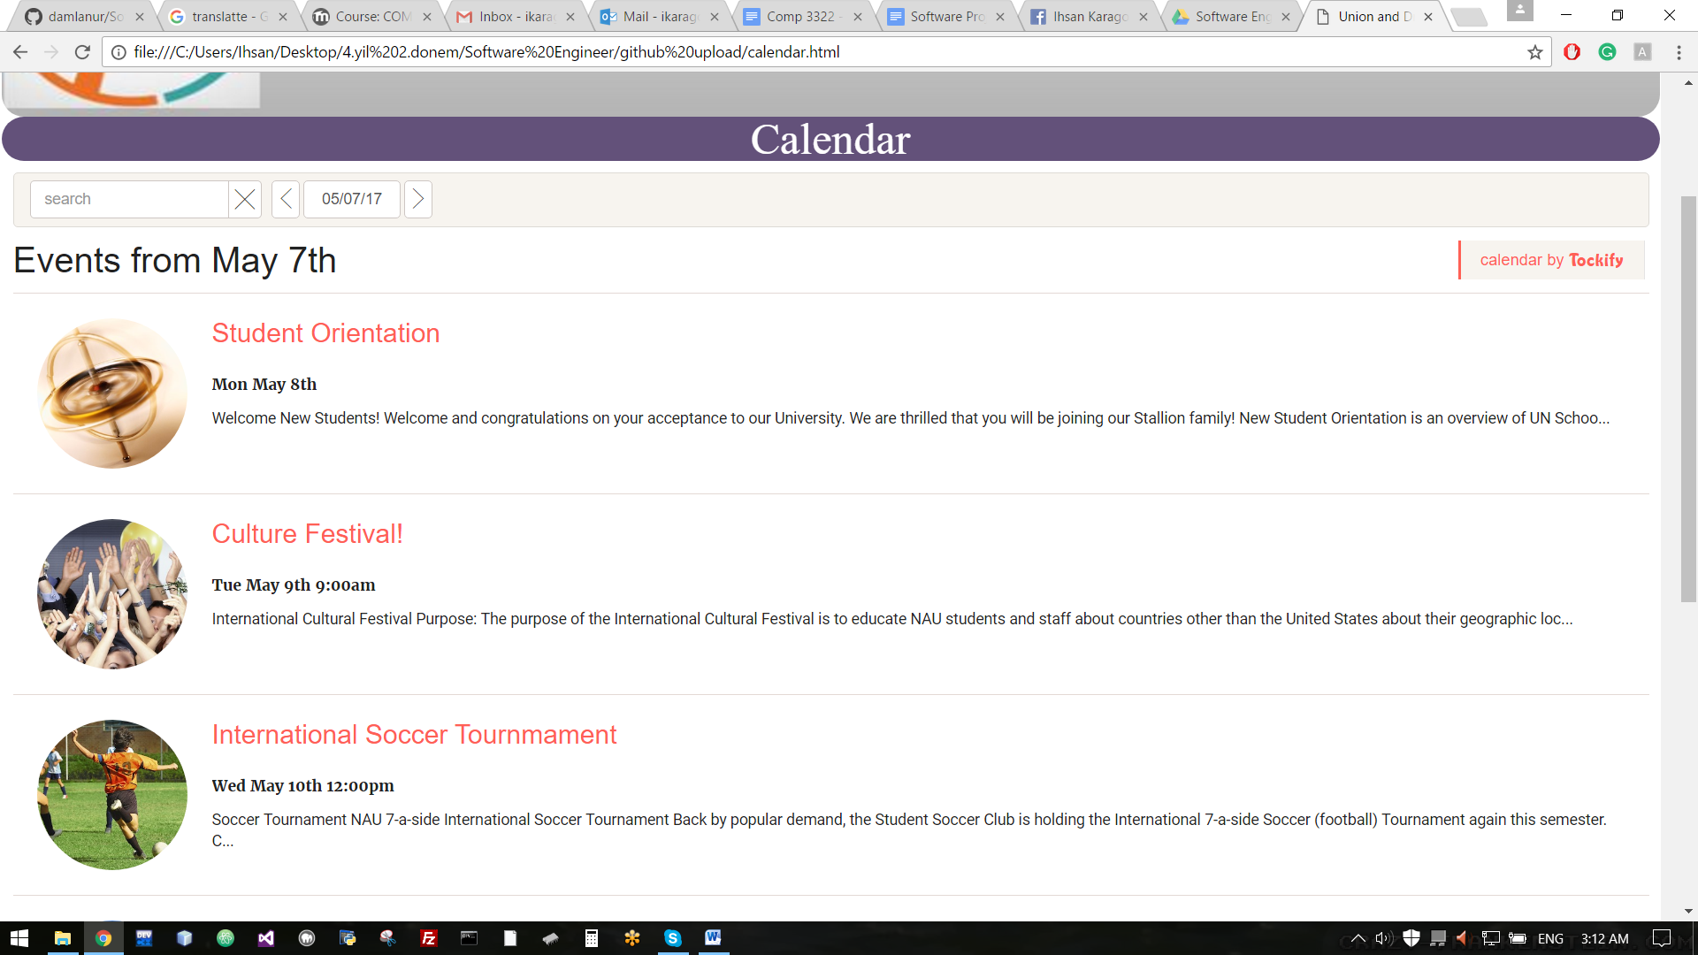 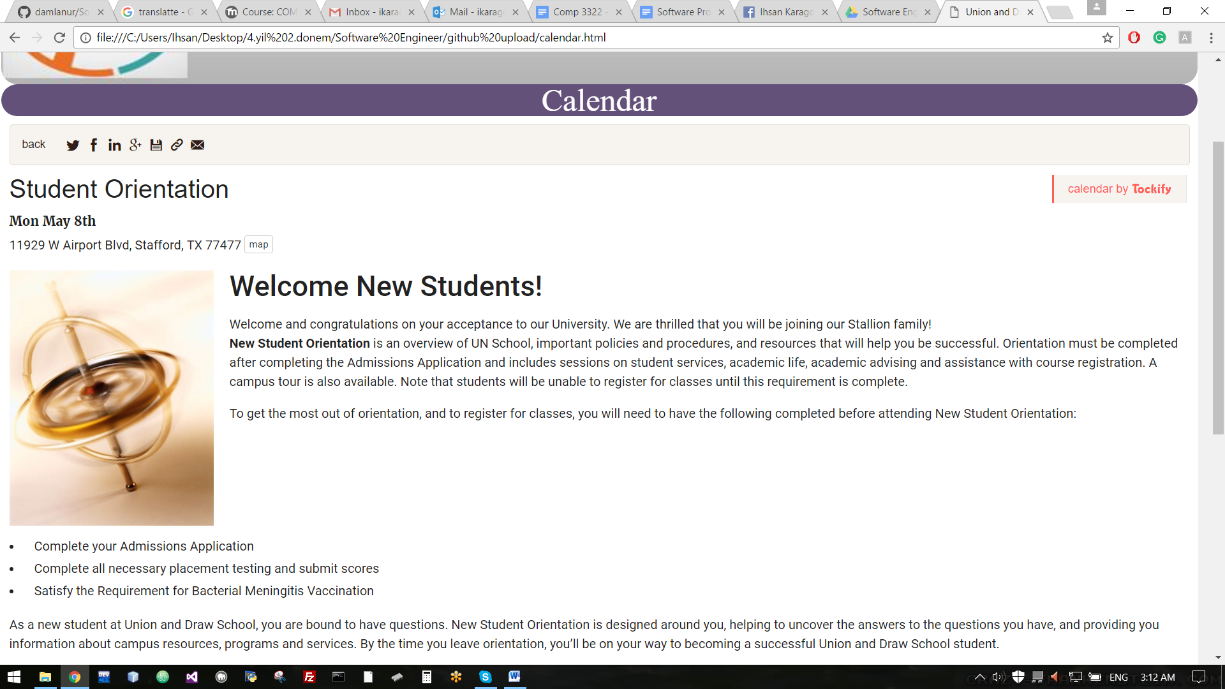 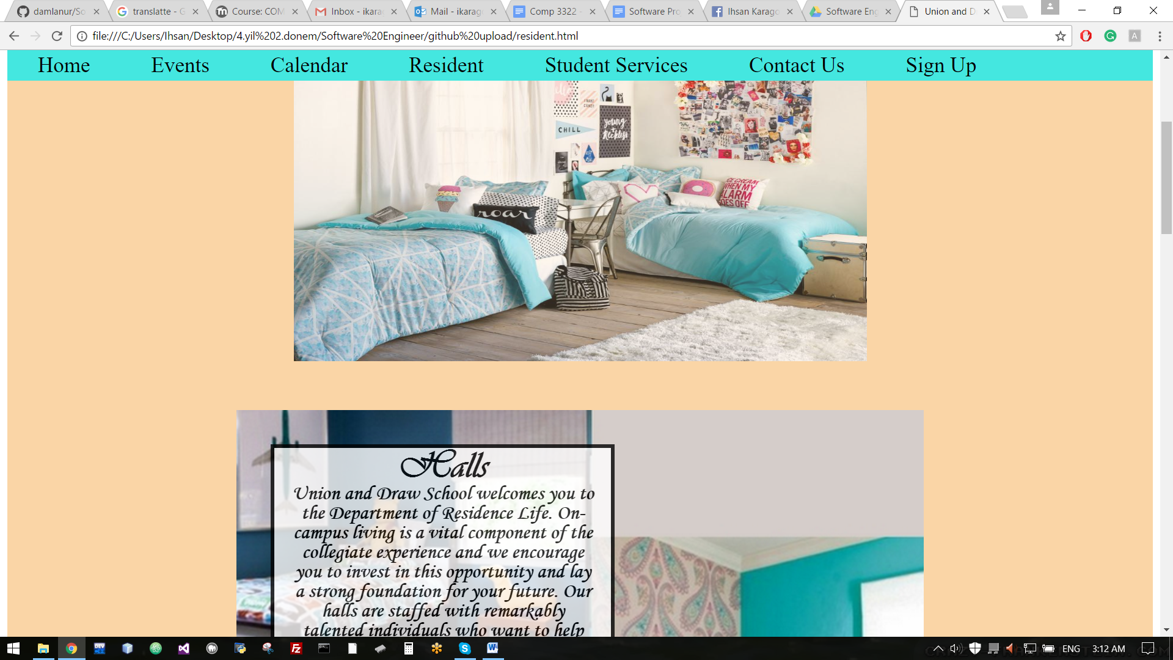 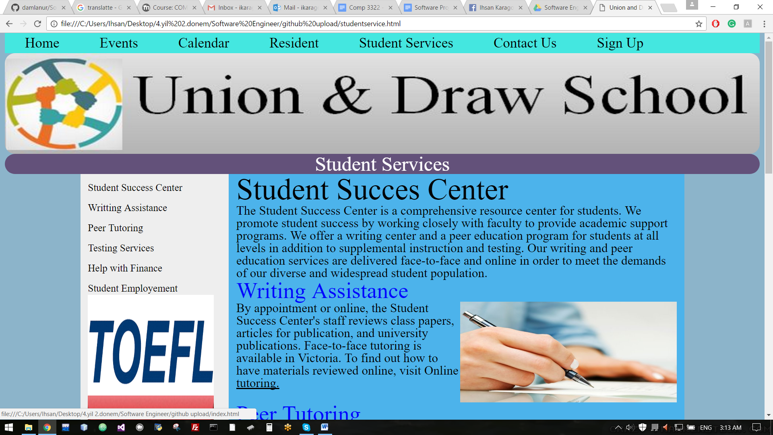 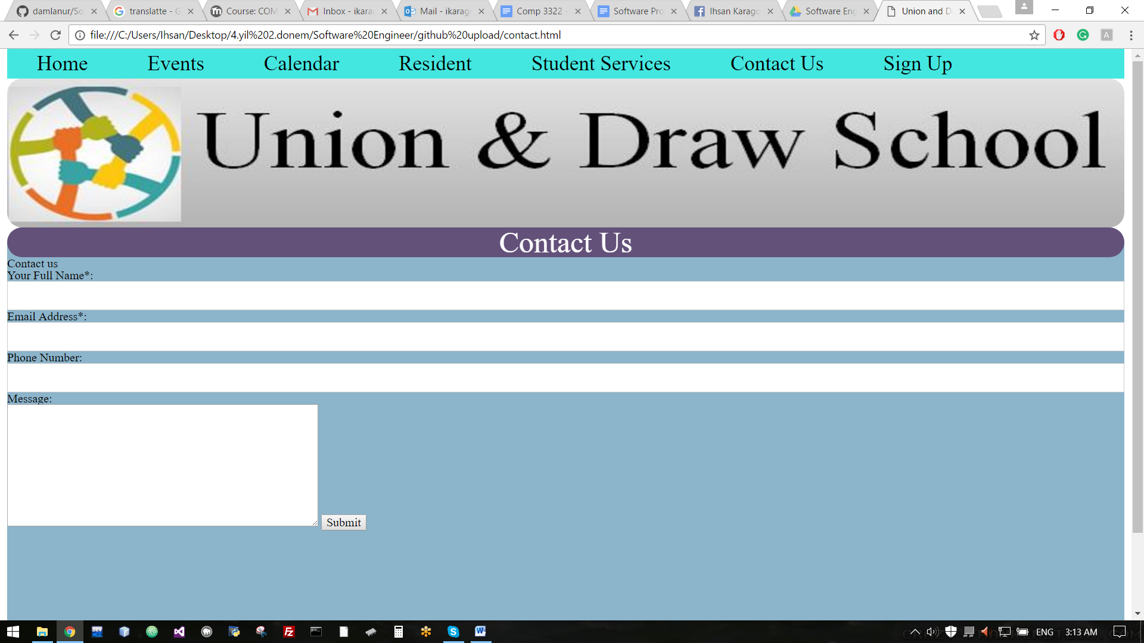 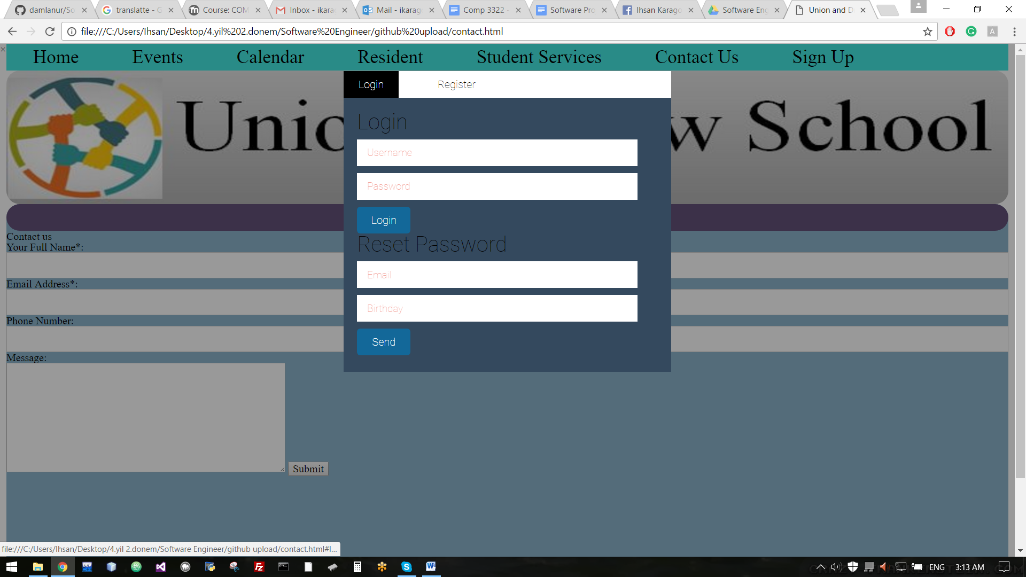 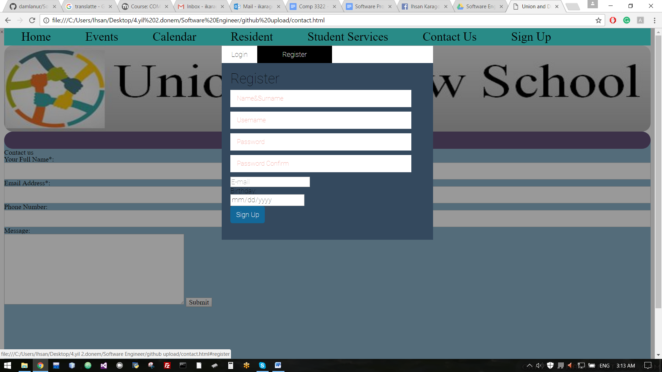

<https://drive.google.com/drive/folders/0B4mSzTZaWzBfTG5xWUplSnE5YnM>

**5.3.1 Repository**

(link of the repository)

**5.3.2 Participation**

(add your link that shows contribution of each member)

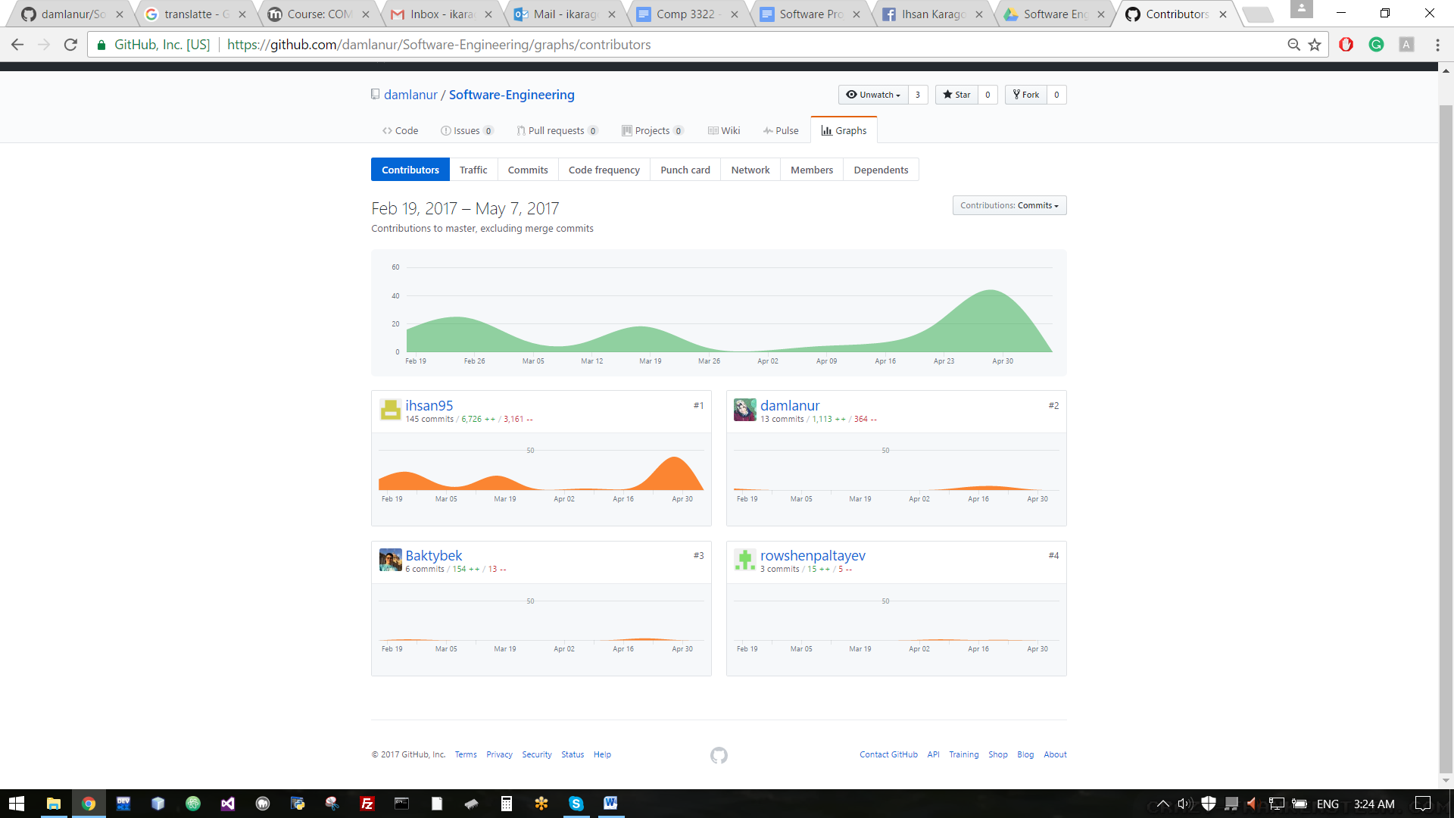

<https://github.com/damlanur/Software-Engineering/graphs/contributors>